6.38: a) 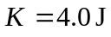, so . b) No work is done between 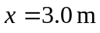 and 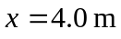, so the speed is the same, 2.00 m/s. c) 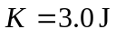, so .

